Lesson 04 – Client-Side Scripting & EF Core

**Using Task List**

1. Open **Task List** window from the menu **VIEW**, **Task List**.

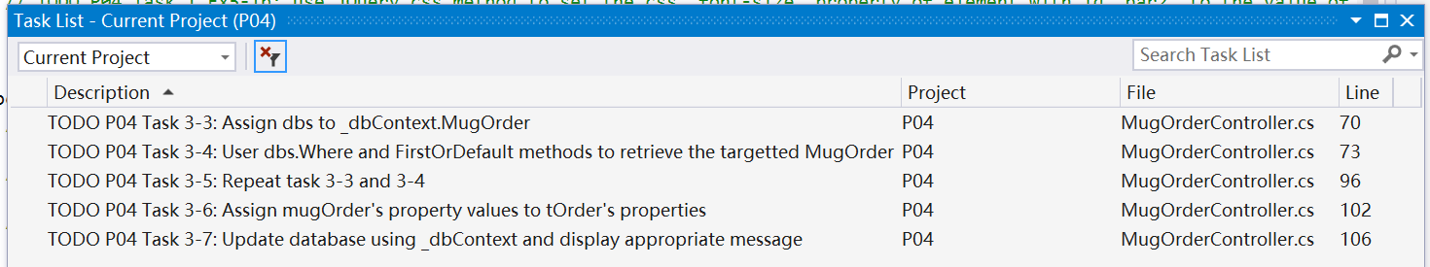

1. **Activity 1 jQuery Exercise:** Open up **Views > ScriptEx > Index.cshtml**.

Complete **Task 1, Exercises 1-5**. Use **Demo.cshtml** and **W3Schools pages** referenced in 6P Part 1 jQuery section to help you. The tasks contains guide for you to complete the exercises as well.

1. **Activity 2:**
   * + 1. Perform **Tasks 2-1 to 2-6**.
       2. **Task 2-1** is in Views/Shared/_Layout.cshtml.
       3. **Tasks 2-2 to 2-6** is in Views/MugOrder/Create.cshtml.
       4. Run the application. Test that mug color and pokedex character image changes based on selection.
2. **Activity 3:** 
   * + 1. Perform **Tasks 3-1 to 3-7**.
       2. **Tasks 3-1 to 3-2** is in Views/MugOrder/Update.cshtml.
       3. Run the application and test update the mug color and pokedex character image changes according to the selection when doing update and the update can be successfully updated to database.
3. **Activity 4:** Use the following steps as guide to use partial view in both **Views/MugOrder/Create.cshtml** and **Views/MugOrder/Update.cshtml**
   * + 1. Create an empty partial view named **_MugOrder.cshtml**
          1. Right-click on **Views > Shared** folder to add new item. Select **Razor View – Empty** (older version of VS may not have the **Empty** word) and name the new view page **_MugOrder.cshtml**:

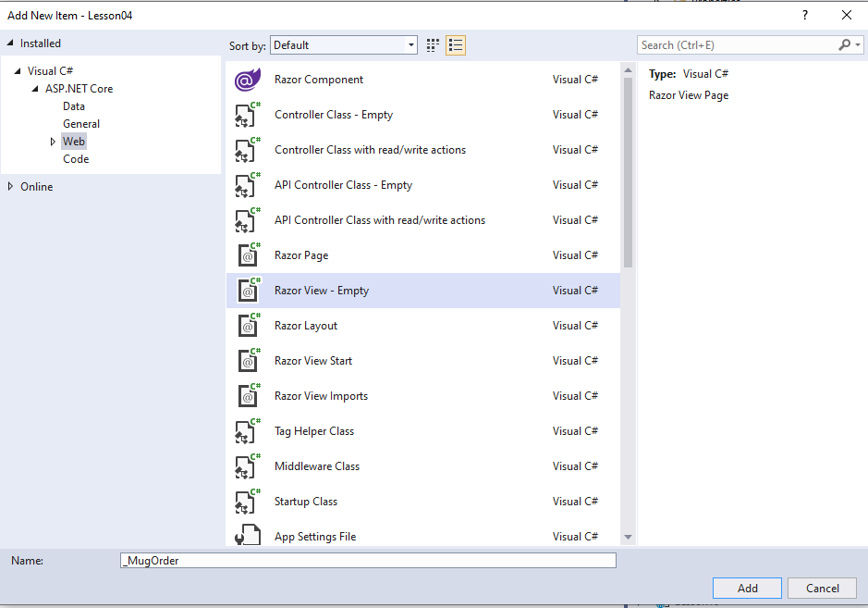

* + - * 1. Ensure that the new **_MugOrder.cshtml** is added to **Views > Shared** folder.
      1. Transfer the common code between **Create.cshtml** and **Update.cshtml** to **_MugOrder.cshtml**.
         1. Delete all content in **_MugOrder.cshtml** and strongly-type it to **MugOrder:**

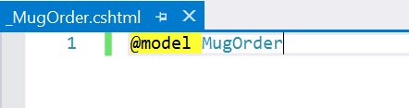

* + - * 1. Cut and paste the highlighted code as shown below from **Create.cshtml** to **_MugOrder.cshtml**:

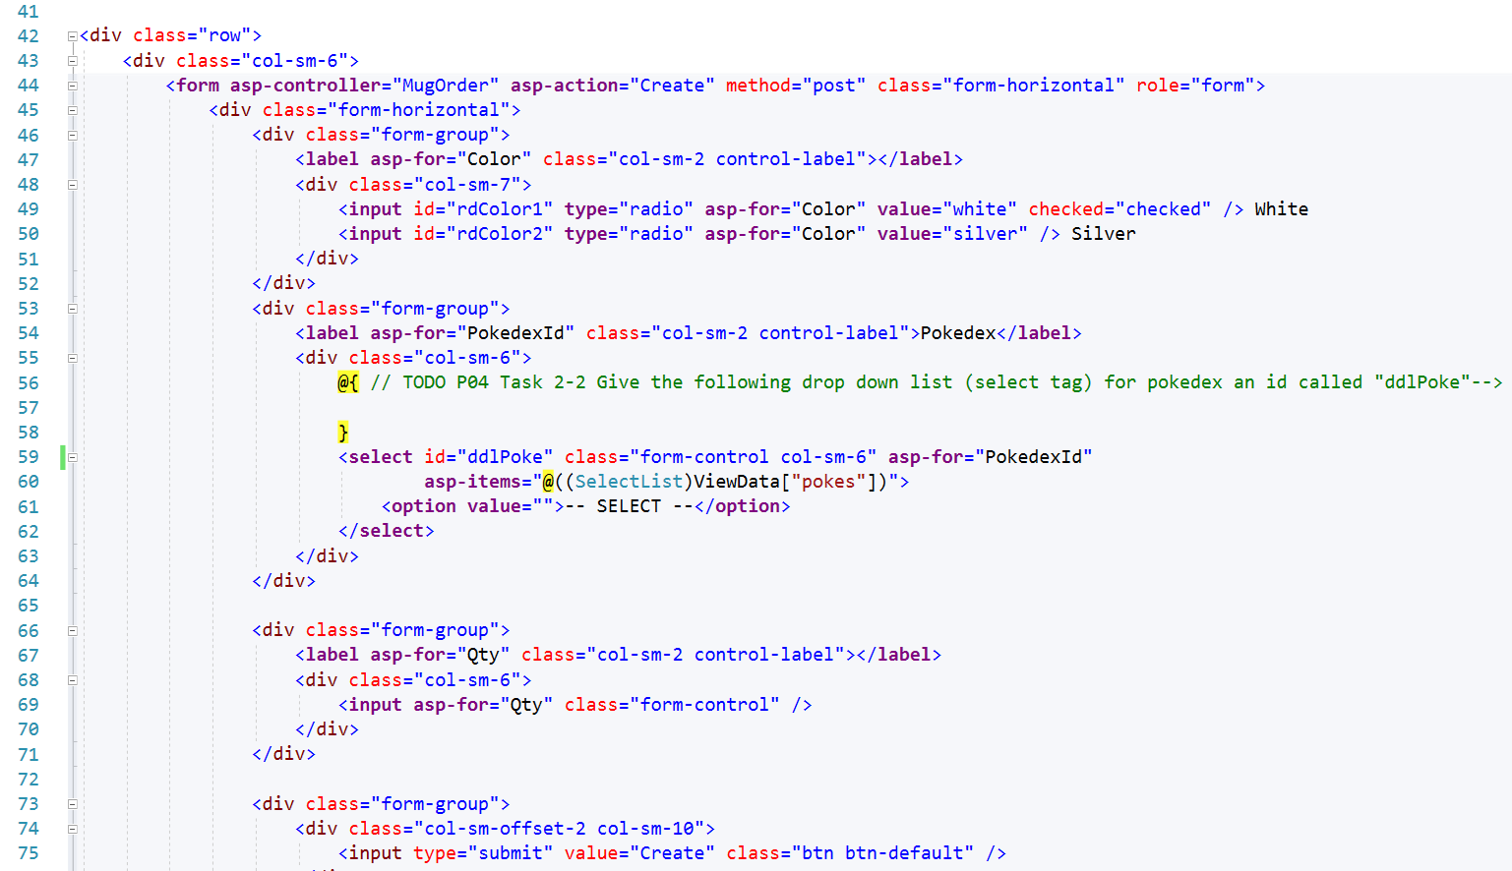

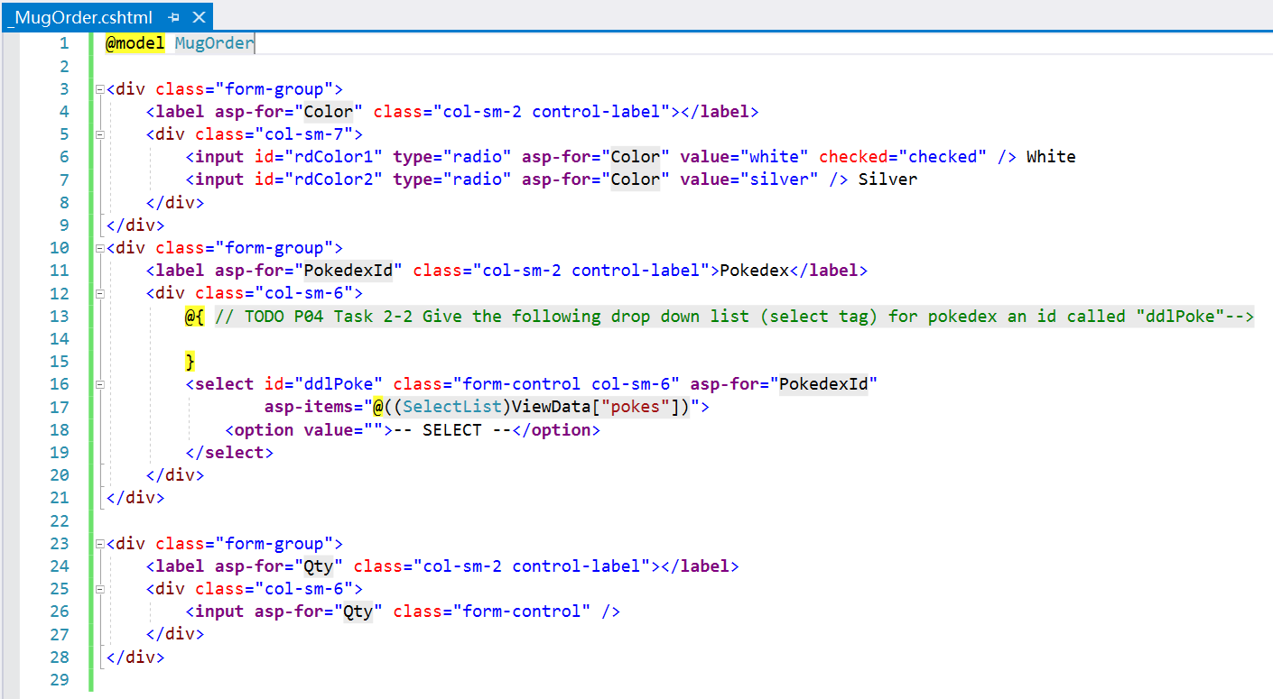

* + - 1. Render partial view **_MugOrder.cshtml** in **Create.cshtml**  and **Update.cshtml**
         1. Use **partial** tag helper to render **_MugOrder.cshtml** in **Create.cshtml**:

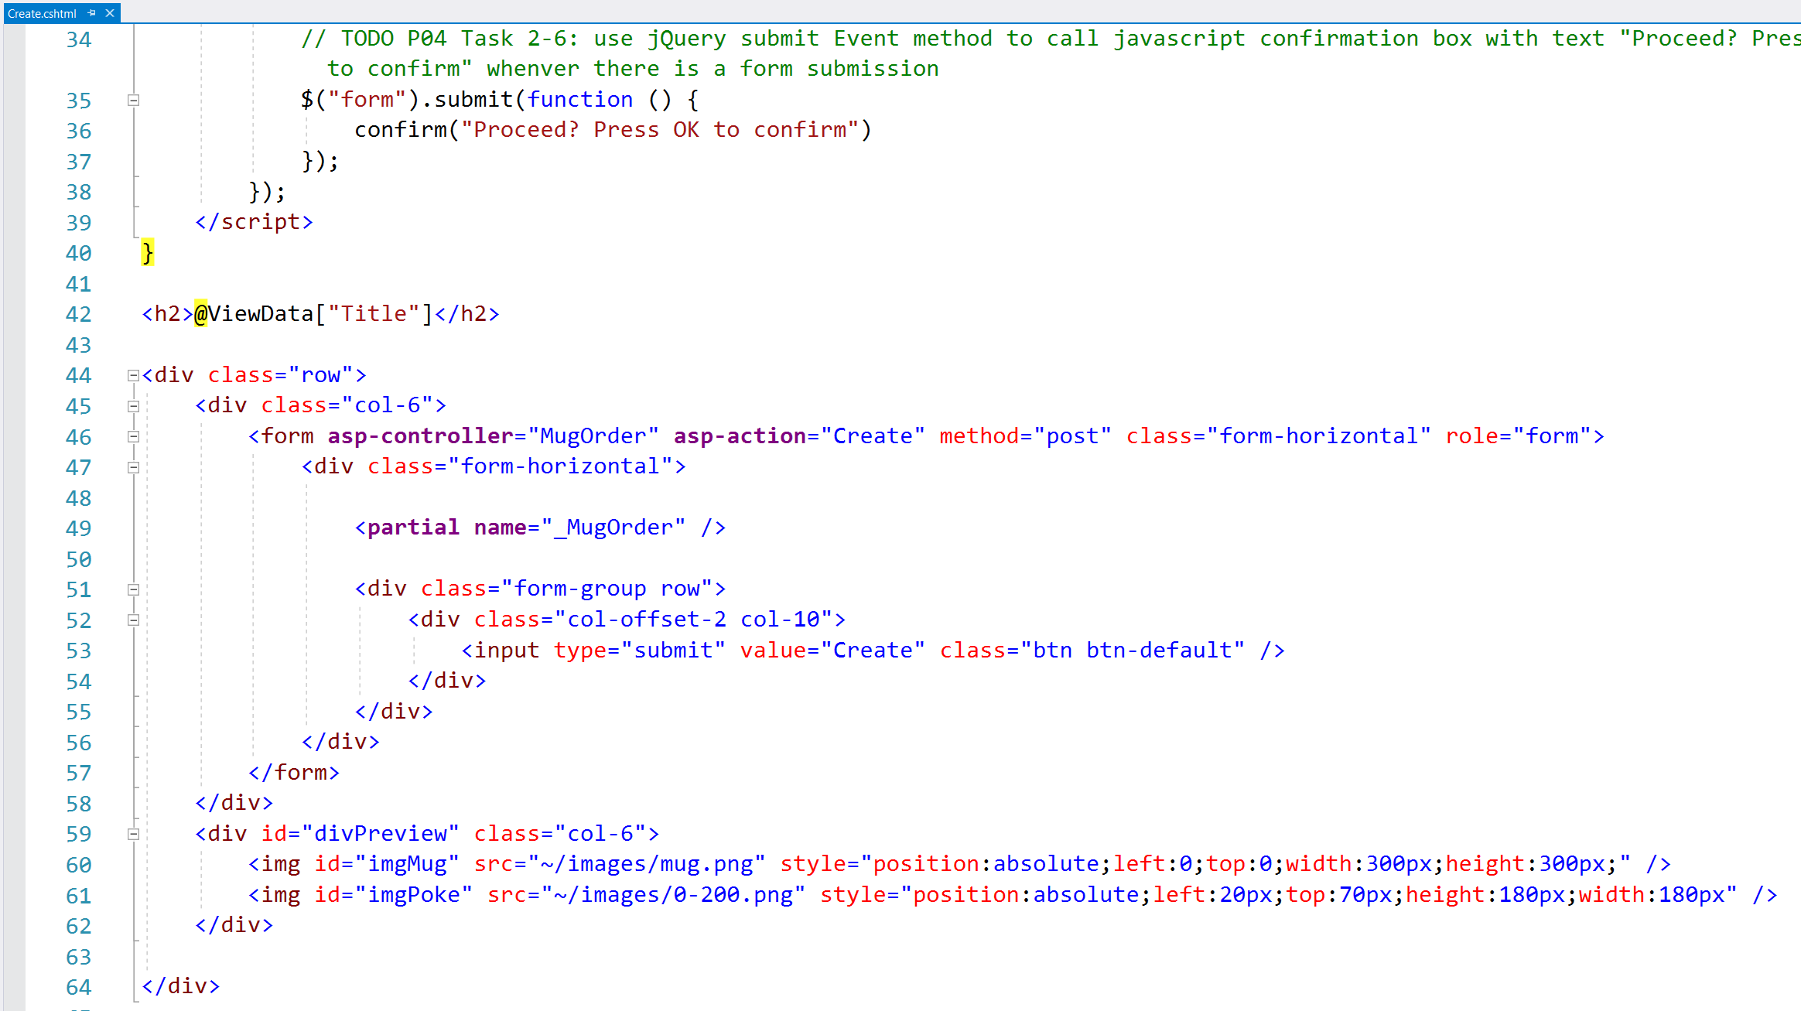

* + - * 1. Delete the highlighted code as shown below from **Update.cshtml**:

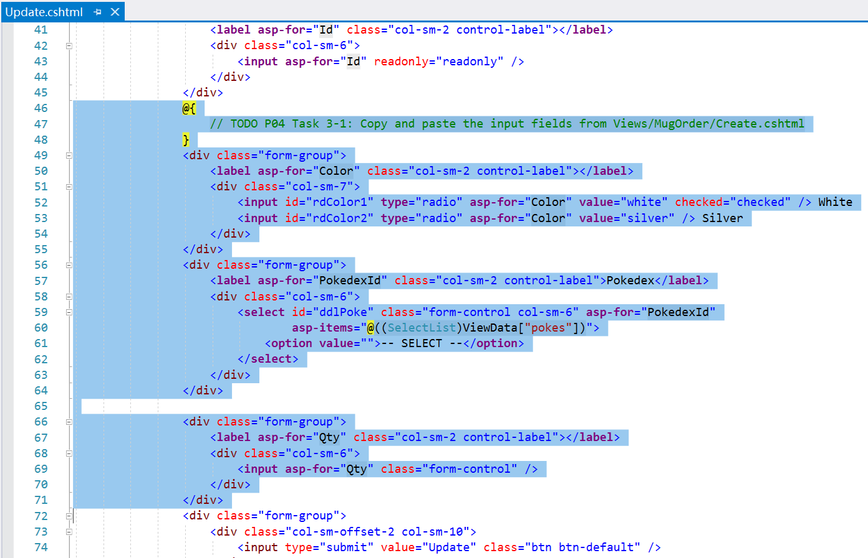

* + - * 1. Use **partial** tag helper to render **_MugOrder.cshtml** in **Update.cshtml**:

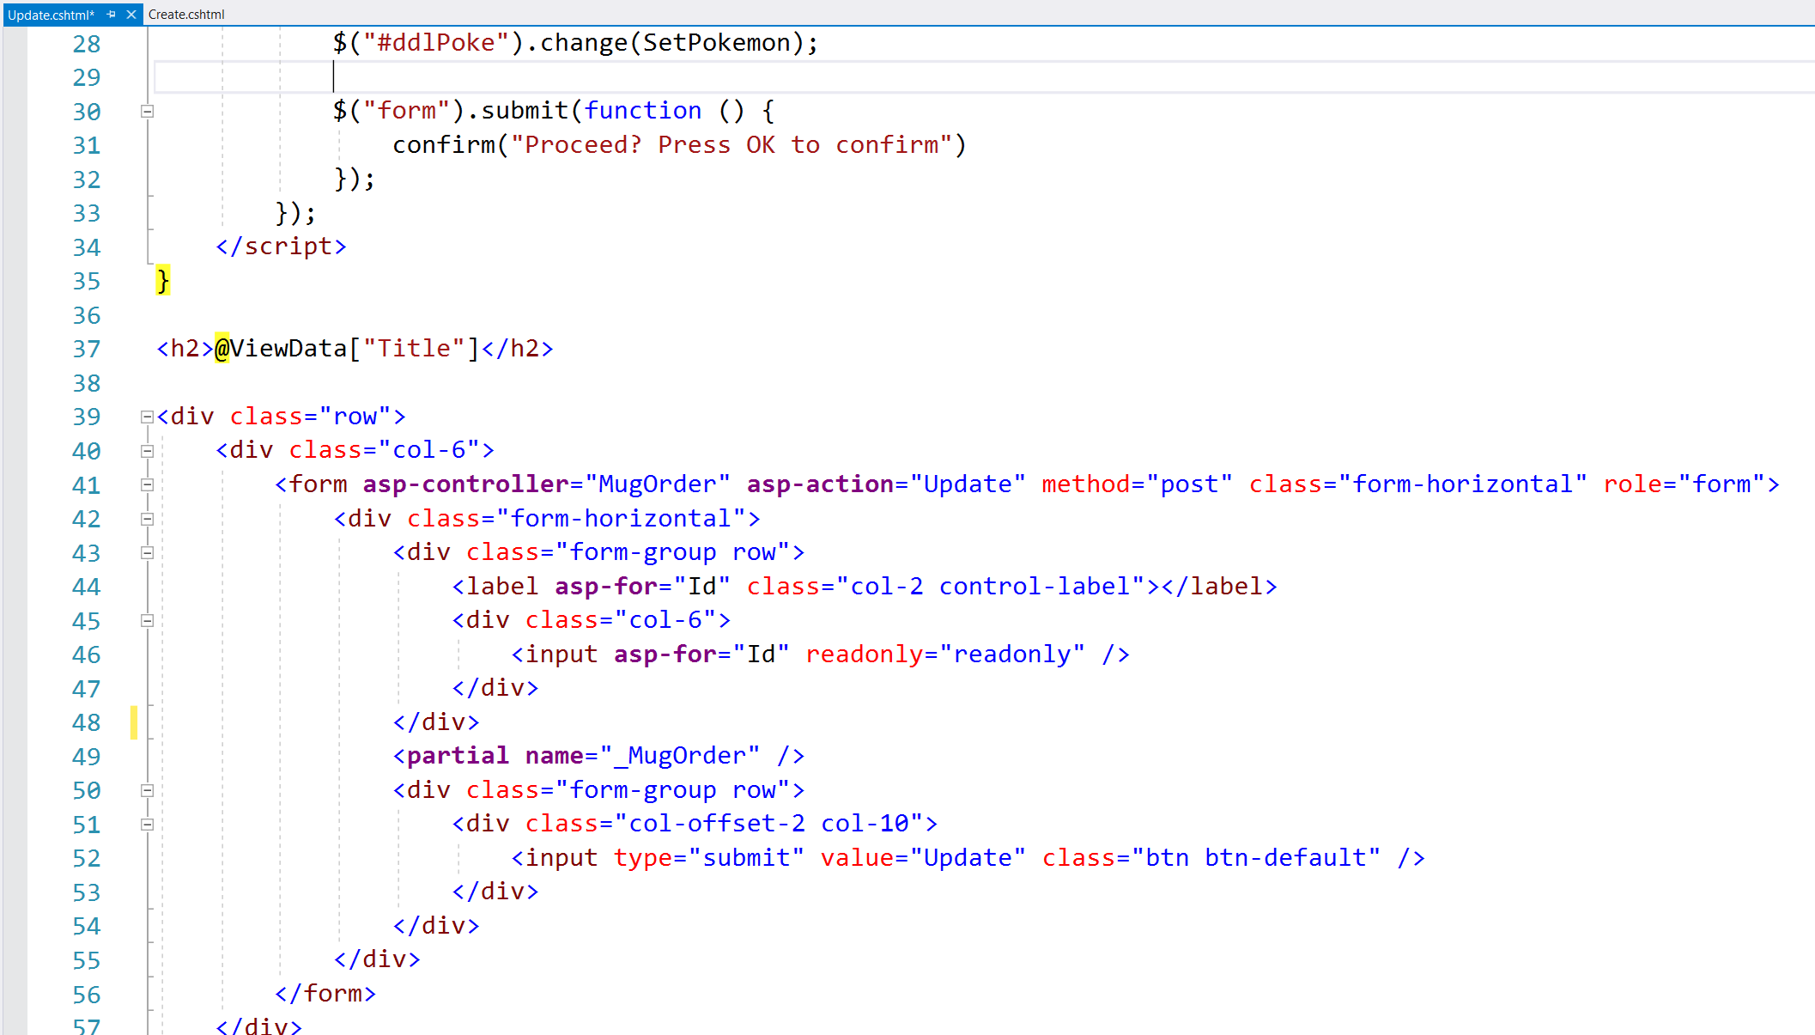

* + - 1. Run the application and verify that the create and update operations work as before.

# Solving the Problem

1. You are suggested to complete the solution in the following order:
   * + 1. Complete the jQuery interactivity requirements in Views/ShirtOrder/Create.cshtml.
       2. Create partial view _ShirtOrder.cshtml and render it in Views/ShirtOrder/Create.cshtml.
       3. Implement ShirtOrderController/Update action.
       4. Implement the jQuery interactivity requirements in Views/ShirtOrder/Update.cshtml.
2. Do you realize the updated color, pokedex and logo position are not reflected when you click on the Update link from Index view? Use the following code to fix it:



8. (**Activity 5**) report with buyers’ fullname: Modify **HomeController.cs** and **Views/Home/Report.cshtml**

# Testing Your Solution

9. Test Cases:

* + - 1. Add a new shirt order and update the shirt order again.

* + - 1. Test all UI interactivities in both Create.cshtml and Update.cshtml: color changes, pokedex changes and front logo position.

* + - 1. Verify that the correct shirt orders are displayed in Index view.

Provide necessary screenshots here to prove you have successfully tested your web app.

*— End of Worksheet —*